**Aim**

To write a C program that concatenates two arrays into a single array.

**Algorithm**

1. Start
2. Input size of first array and its elements
3. Input size of second array and its elements
4. Create a third array of size (n1 + n2)
5. Copy all elements of first array into third array
6. Copy all elements of second array into third array (continuing after first array)
7. Display the concatenated array
8. Stop

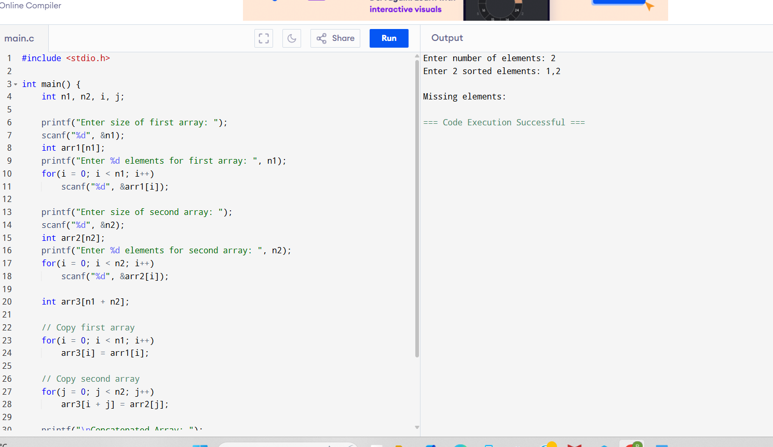

**Output**

Concatenated Array: 10 20 30 40 50 60 70